Works Department

*Submitted in partial fulfillment of the requirements for the award of the degree of*

**Bachelor of Computer Applications (BCA)**

To

Guru Gobind Singh Indraprastha University, Delhi

**Guide: Submitted By:**

## Ms. Suman Singh Anmol Garg (00821102020)

(Assistant Professor) Harsh Mahori (02221102020)

**Institute of Information Technology & Management, New Delhi – 110058**

**Batch (2020-2023)**

**Certificate**

We, **Anmol Garg (00821102020) & Harsh Mahori (02221102020)** certify that the Minor Project Report (BCA-357) entitled **“Food Ordering Website”** is done by us and it is an authentic work carried out by us at Institute of Information, Technology and Management. The matter embodied in this project work has not been submitted earlier for the award of any degree or diploma to the best of my knowledge and belief.

Signature of the Students Date: 26-12-2022

Certified that the Project Report (BCA-357) entitled **“Food Ordering Website”** done by the above students is completed under my guidance.

Signature of the Guide: Date: 26-12-2022

Name of the Guide: Ms. Suman Singh Designation: Assistant Professor

Countersign Countersign

Head of the Department Director

# ACKNOWLEDGEMENT

This is a great opportunity to acknowledge the remarkable contribution of all the persons whose support makes this project **“Food Ordering Website”** a reality.

We would like to add a few heartfelt words for the people who were part of this project in numerous ways.

It is my privilege to express deep sense of gratitude to my guide **Ms. Suman Singh, Assistant Professor, Institute Of Information Technology and Management, GGSIPU, New Delhi**, for her exemplary guidance, monitoring and encouragement throughout the course of this project. The blessing, benevolent discipline and guidance given by her time shall carry us a long way in the journey of life on which we about to embark.

We deeply indebted to all teaching and non-teaching staffs of our Institute for their continuous support and motivation.

Last but not the least, we would like to acknowledge the constant support of my parents and family members, friends whose patience and encouragement during project completion helped in making this project a reality.

Name: Anmol Garg (00821102020)

Harsh Mahori (02221102020)

|  |  |  |
| --- | --- | --- |
| **S No** | **Topic** | **Page No** |
| 1. | Certificate | - |
| 2. | Acknowledgements | - |
| 3. | List of Tables/Figures/Symbols | - |
| 4. | Synopsis | 1-3 |
| 5. | Chapter-1: Introduction | 4-11 |
| 6. | 1 Description of the Organization | 4-5 |
| 7. | 2 Software Requirement Specification | 6 |
| 8. | 3 Overview | 7 |
| 9. | 4 Assumptions and Dependencies | 7 |
| 10. | 5 System Interfaces | 7 |
| 11. | 6 User Interfaces | 8-9 |
| 12. | 7 Memory Constraints | 9 |
| 13. | 8 Specific Requirements | 9-11 |
| 14. | Chapter-2: System Design | 12-21 |
| 15. | 1 Physical Design | 12 |
| 16. | 2 Block Diagram | 12 |
| 17. | 3 Use Case Diagram | 13 |
| 18. | 4 Data Flow Diagram | 13-17 |
| 19. | 5 Entity Relationship Diagram | 18-21 |
| 20. | Chapter-3: Scope of Improvement, Summary and Conclusions | 22 |
| 21. | 1 Scope of Improvement | 22 |
| 22. | 2 Summary | 22 |
| 23. | 3 Conclusion | 22 |
| 24. | Appendices | 23 |

|  |  |  |
| --- | --- | --- |
| **Figure No** | **Title** | **Page No** |
| 2.1 | Block Diagram | 12 |
| 2.2 | Use Case Diagram | 13 |
| 2.3 | Level-0 DFD | 14 |
| 2.4 | Level-1 DFD | 15 |
| 2.5 | Level-2 DFD (Manage Complaint) | 16 |
| 2.6 | Level-2 DFD (Manage Status) | 17 |
| 2.7 | ERD | 18 |

**SYNOPSIS**

### INTRODUCTION OF THE PROJECT:

The Work Department System is a cutting-edge project designed to streamline and enhance the customer experience by providing a seamless platform for clients to lodge complaints, track their progress, and provide valuable feedback on the services received. It aims to empower clients by offering them a user-friendly and convenient interface through which they can communicate their concerns, monitor the resolution process, and ultimately contribute to the improvement of services.

### OBJECTIVE:

* + Efficient Complaint Lodging
  + Real-time Status Tracking

### SCOPE:

* + Complaint Lodging
  + Real-time Status Tracking
  + Complaint Resolution Workflow
  + Feedback Collection

### SYSTEM STUDY:

* 1. **HARDWARE SPECIFICATIONS:**

|  |  |
| --- | --- |
| **Categories** | **Requirement** |
| RAM | 2 GB (and higher) |
| HDD | 5 GB (and higher) |
| Processor | i3 (and higher) |

**Table 1: Hardware requirement**

* 1. **SOFTWARE SPECIFICATIONS:**

|  |  |
| --- | --- |
| **Software** | **Requirement** |
| Operating System | Windows (7 and higher), Mac (10.12 and higher), Linux (ubuntu 14.10) |
| Front-End | Html 5, CSS 3, React 16.8.6, Express 3.18.1,  , Tailwind CSS 3.1.7 |
| Back-End | MySql 8.0, NodeJS 16.14.2 |

**Table 2: Software requirement**

1. **METHODOLOGY:**

The methodology employed in an experiment is essential to its success, and bad methodology has spoiled thousands of research projects. So, whenever a piece of research is published in a scientific or medical journal, the researchers always carefully describe their methodology; otherwise, other scientists couldn't possibly judge the quality of what they've done.

### SDLC MODEL:

Software Development life cycle (SDLC) is a spiritual model used in project management that defines the stages include in an information system development project, from an initial feasibility study to the maintenance of the completed application.

**Prototype Model:** The prototyping model starts with the requirements gathering. The developer and the user meet and define the purpose of the software, identify the needs, etc.

A '**quick design**' is then created. This design focuses on those aspects of the software that will be visible to the user. It then leads to the development of a prototype. The customer then checks the prototype, and any modifications or changes that are needed are made to the prototype.

Looping takes place in this step, and better versions of the prototype are created. These are continuously shown to the user so that any new changes can be updated in the prototype. This process continue until the customer is satisfied with the system. Once a user is satisfied, the prototype is converted to the actual system with all considerations for quality and security.

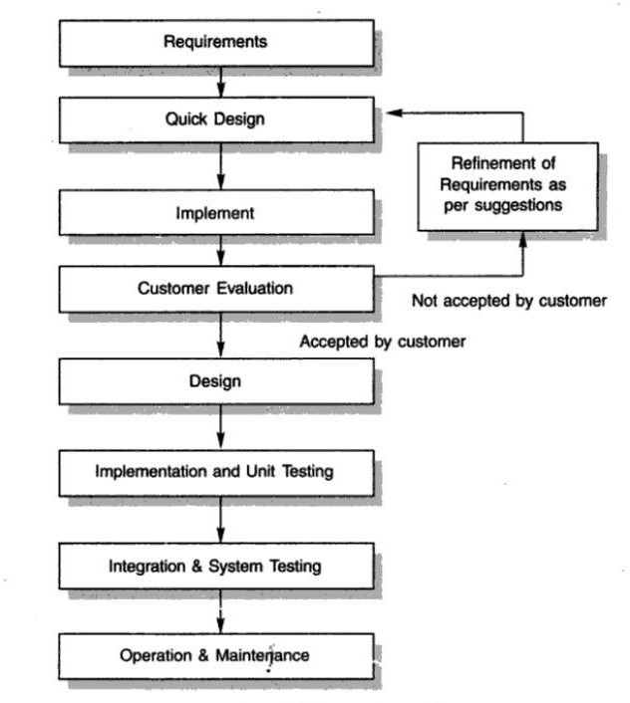

### Fig 1: Prototype model explaining the working of website

**CHAPTER - 1 INTRODUCTION**

1. **DESCRIPTION OF ORGANIZATION:**

The Work Department System is a cutting-edge project designed to streamline and enhance the customer experience by providing a seamless platform for clients to lodge complaints, track their progress, and provide valuable feedback on the services received. It aims to empower clients by offering them a user-friendly and convenient interface through which they can communicate their concerns, monitor the resolution process, and ultimately contribute to the improvement of services.

.

### Role of Users:

* + - * View Profile
      * View Summary
      * Lodge Complaint
      * Check Status

### Role of Admin:

* CRUD Complaint Status
* View Complaints Feedback
* View Workers Profile

### INTRODUCTION:

Existing system is manual system. It requires a lot of manual work to be done, it is a time-consuming system. The existing system is maintained by hand, without using computer system. Earlier the user had to go to the department to lodge the complaint and wait for its completion.

The Work Department System is a cutting-edge project designed to streamline and enhance the customer experience by providing a seamless platform for clients to lodge complaints, track their progress, and provide valuable feedback on the services received. It aims to empower clients by offering them a user-friendly and convenient interface through which they can communicate their concerns, monitor the resolution process, and ultimately contribute to the improvement of services of the workers to whom assigned

### HISTORY OF ORGANIZATION:

None

### OBJECTIVE OF ORGANIZATION:

* Efficient Complaint Lodging
* Real-time Status Tracking

### FUNCTIONS:

* Allow clients to create accounts and log in securely.
* Provide a user-friendly interface for clients to lodge complaints..
* Provide real-time updates and notifications as the status of complaints changes..
* Allow clients to provide feedback once their complaints are successfully resolved..

### DESCRIPTION OF PROPOSED INFORMATION SYSTEM:

* + 1. **Signup**

This process is for both Admin and User. He/she will enter their Username and Password to get access to processes like Profile, Summary etc.

### Summary

The summary module lets users to check the complaints state that he/she has lodged.

### Lodge Complaint

### The lodge complaint module allows the users to lodge the complaint by selecting the complaint type and writing the complaint

### SOFTWARE REQUIREMENT SPECIFICATIONS:

* 1. **INTRODUCTION:**

It is complete specification and description of requirements of software that needs to be fulfilled for successful development of software system. These requirements can be functional as well as non-functional depending upon type of requirement.

The following subsections of Software Requirement Specifications Document should facilitate in providing the entire overview of the Information system “Works Department” under development. This document aims at defining the overall software requirements for our website. Efforts have been made to define the requirements of the Information system exhaustively and accurately.

### PURPOSE:

The main purpose of Software Requirement Specifications Document is to describe in a precise manner all the capabilities that will be provided by the Software Application “Works Department”. It also states the various constraints which the system will be abide to. This document further leads to clear vision of the software requirements, specifications and capabilities. These are to be exposed to the development, testing team and end users of the software.

### SCOPE:

* + Complaint Lodging
  + Real-time Status Tracking
  + Complaint Resolution Workflow
  + Feedback Collection

### REFERENCES:

1. Tailwind CSS - <https://tailwindui.com/components?ref=sidebar>
2. K.K. Aggarwal & Yogesh Singh, “Software Engineering”, 2nd edition, New Age International, 2005.
3. R.S. Pressman, “Software Engineering – A practitioner’s approach”, 5th edition, PHI Learning Private Limited.
4. Jeffery C. Jackson, “Web Technologies: A Computer Science Perspective”, Pearson.
5. Internet and World Wide Web Deitel HM, Deitel, Goldberg, Third edition.

### OVERVIEW:

The rest of this SRS document describes the various system requirements, interfaces, features and functionality in detail.

### OVERALL DESCRIPTION OF PROPOSED SYSTEM:

The Work Department System is a cutting-edge project designed to streamline and enhance the customer experience by providing a seamless platform for clients to lodge complaints, track their progress, and provide valuable feedback on the services received. It aims to empower clients by offering them a user-friendly and convenient interface through which they can communicate their concerns, monitor the resolution process, and ultimately contribute to the improvement of services

### PRODUCT PERSPECTIVE:

The application will be windows-based, self-contained and independent software product.

Front End Client Application (with data entry / update / delete / view and reporting facility)

Backend Database

### Fig 1.1: Interaction of Product with the environment

1. **ASSUMPTIONS AND DEPENDENCIES:**

The application is developed on the following assumptions.

* The Users has all the available hardware required to support the intended user load.
* Works Department depends on Information, Posts and data stored in database and hence these systems and database servers should be up and available for normal functioning of Works Department.

### SYSTEM INTERFACES:

None

### USER INTERFACES:

The application will have a user friendly and menu-based interface. Following screens will be provided.

* A clean and simple interface to allow users to register or log in with their credentials.Fields for entering username and password.
* On the Summary, user can see the details of the complaints they have been lodged and can view each complaint details and can also modify or delete it.
* User can lodge complaint by selecting the complaint type and write the necessary complaint.

### HARDWARE INTERFACES:

|  |  |
| --- | --- |
| **Categories** | **Requirement** |
| RAM | 2 GB (and higher) |
| HDD | 5 GB (and higher) |
| Processor | i3 (and higher) |

**Hardware requirement**

* 1. **SOFTWARE INTERFACES:**

|  |  |
| --- | --- |
| **Software** | **Requirement** |
| Operating System | Windows (7 and higher), Mac (10.12 and higher), Linux (ubuntu 14.10) |
| Front-End | Html 5, CSS 3, React 16.8.6, Express 3.18.1,  Tailwind CSS 3.1.7 |
| Back-End | MySql 8.0, NodeJS 16.14.2 |

**Software requirement**

* 1. **COMMUNICATION INTERFACES:**

None

### MEMORY CONSTRAINTS:

**7.1 OPERATIONS:**

This product will not cover any automated housekeeping aspects of database. The DBA at client site will be manually deleting old/ non required data. Database backup and recovery will also have to be handled by DBA.

### SPECIFIC REQUIREMENTS:

This section contains the software requirements to a level of detail sufficient to enable designers to design the system, and testers to test the system.

### USER CHARACTERISTICS:

* + 1. **Educational Level:** At least graduate and should be comfortable with English language.
    2. **Technical Expertise:** Should be a high or middle level employee of the organization comfortable with using general purpose applications on a computer.

### PRODUCT FUNCTIONS:

The system will allow access only to authorized users with specific roles (Administrator, Operator). Depending upon the user’s role, he/she will be able to access only specific modules of the system.

A summary of the major functions that the software will perform:

1. A Login facility for enabling only authorized access to the system.
2. Users will be able to add/update/delete the complaint.
3. Users will be able to give feedback.
4. Admin will be able to assign/update/delete the complaint.
5. Admin manages the status of complaint.

### SYSTEM FEATURES:

**8.3.1 MODULE:**

1. **Lodge Complaint:** Used for lodging complaint.
2. **Summary:** Used to show the summary of complaint
3. **Status:** Used to show details of a single complaint.
4. **Feedback:** Used for giving feedback to the service
5. **Profile:** Used for managing the Client information
6. **Login:** Used for managing the login details

### PERFORMANCE REQUIREMENTS:

None

* 1. **LOGICAL DATABASE REQUIREMENTS**

The proposed information system contains the following data tables in its database collection.

* client
* complaints
* assigned
* feedback
* workers

### DESIGN CONSTRAINTS

Standard Compliance None

### Software System Attributes

* + 1. **Reliability**

This application is a reliable product that produces fast and verified output of all its processes.

### Availability

This application will be available to use for users and help them to carry out their operations conveniently.

### Security

The application will be password protected. User will have to enter correct username and password in order to access the application.

### Maintainability

The application will be designed in a maintainable manner. It will be easy to incorporate new requirements in the individual modules.

### Portability

The application will be easily portable on any windows based system that has oracle installed.

### Other Requirements

None

# CHAPTER - 2 SYSTEM DESIGN

### PHYSICAL DESIGN:

This website manages to streamline and enhance the customer experience by providing a seamless platform for clients to lodge complaints, track their progress, and provide valuable feedback on the services received. It aims to empower clients by offering them a user-friendly and convenient interface through which they can communicate their concerns, monitor the resolution process, and ultimately contribute to the improvement of services

.

### Role of Users:

* + - * View Profile
      * View Summary
      * Lodge Complaint
      * Check Status

### Role of Admin:

* CRUD Complaint Status
* View Complaints Feedback
* View Workers Profile

### BLOCK DIAGRAM:

A block diagram is a diagram of a system in which the principal parts or functions are represented by blocks connected by lines that show the relationships of the blocks. They are heavily used in engineering in hardware design, electronic design, software design, and process flow diagrams.

Block diagrams are typically used for higher level, less detailed descriptions that are intended to clarify overall concepts without concern for the details of implementation. Contrast this with the schematic diagrams and layout diagrams used in electrical engineering, which show the implementation details of electrical components and physical construction.

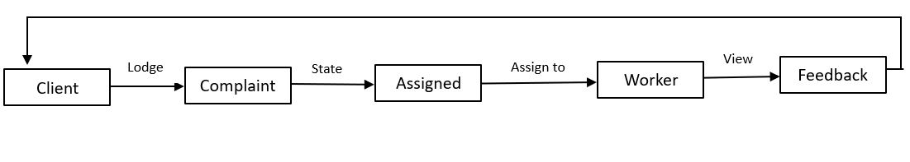

### Fig 2.1: Block diagram

1. **USE CASE DIAGRAM:**

A use case diagram is a graphical depiction of a user's possible interactions with a system. A use case diagram shows various use cases and different types of users the system has and will often be accompanied by other types of diagrams as well. The use cases are represented by either circles or ellipses. The actors are often shown as stick figures.

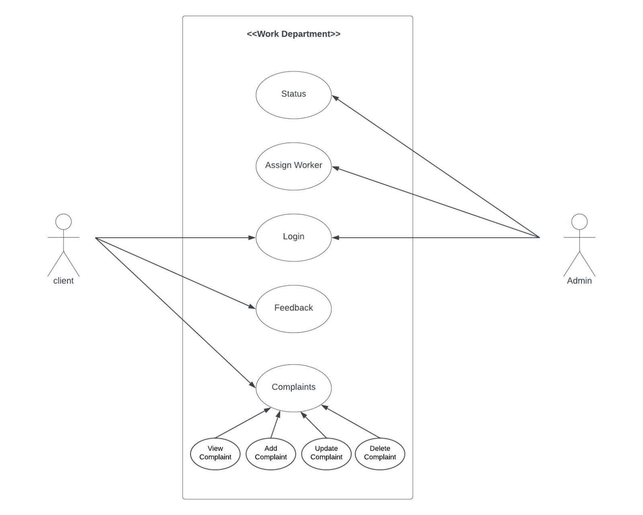

### Fig 2.2: Use case diagram

1. **DATA FLOW DIAGRAMS:**

A data flow diagram (DFD) maps out the flow of information for any process or system. It uses defined symbols like rectangles, circles and arrows, plus short text labels, to show data inputs, outputs, storage points and the routes between each destination. DFD can be drawn to represent the system of different levels of abstraction. Higher level DFDs are partitioned into low levels hacking more information and functional elements. Levels in DFD are numbered 0, 1, 2 or beyond.

1. **level DFD:** It is also known as context diagram. It’s designed to be an abstraction view, showing the system as a single process with its relationship to external entities. It represents the entire system as single bubble with input and output data indicated by incoming/outgoing arrows.

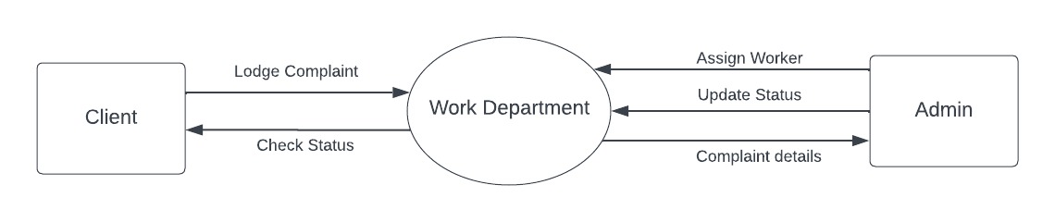

### Fig 2.3: 0 Level Data Flow Diagram (DFD)

1. **level DFD:** In 1-level DFD, context diagram is decomposed into multiple bubbles/processes. In this level we highlight the main functions of the system and breakdown the high-level process of 0-level DFD into sub processes.

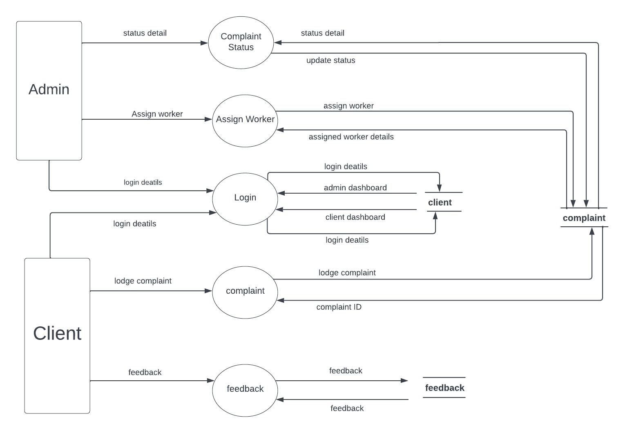

### Fig 2.4: 1 Level Data Flow Diagram (DFD)

1. **level DFD:** 2-level DFD goes one step deeper into parts of 1-level DFD. It can be used to plan or record the specific/necessary detail about the system’s functioning.

### MANAGE COMPLAINT

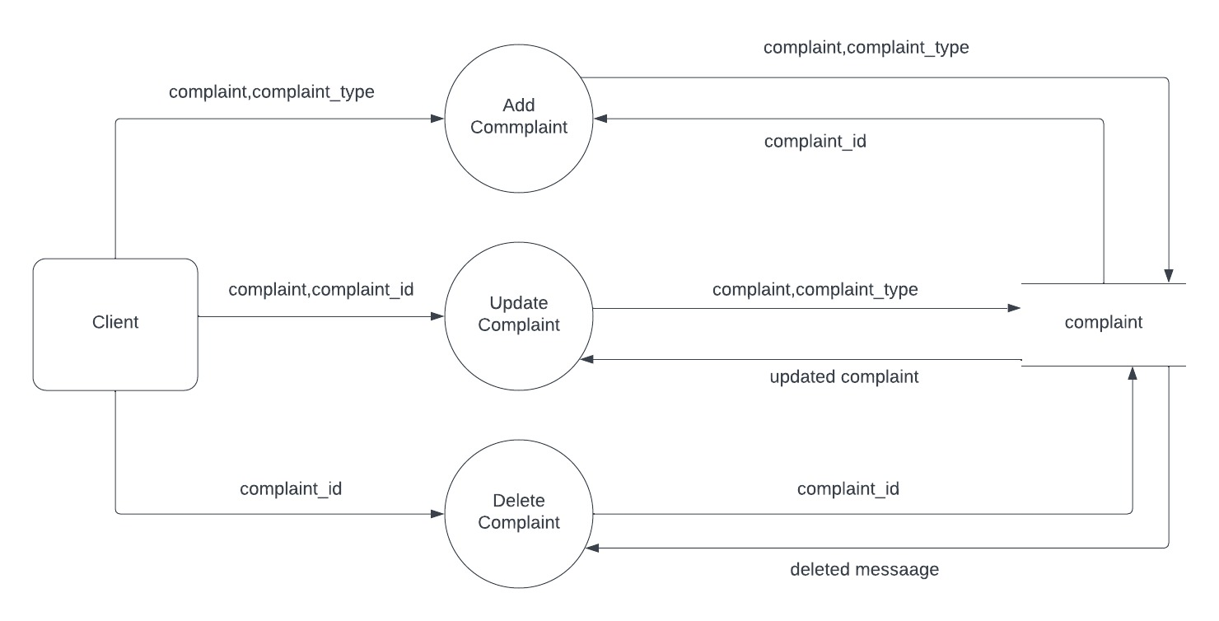

**Fig 2.5: 2 Level Data Flow Diagram (DFD)**

**MANAGE STATUS**

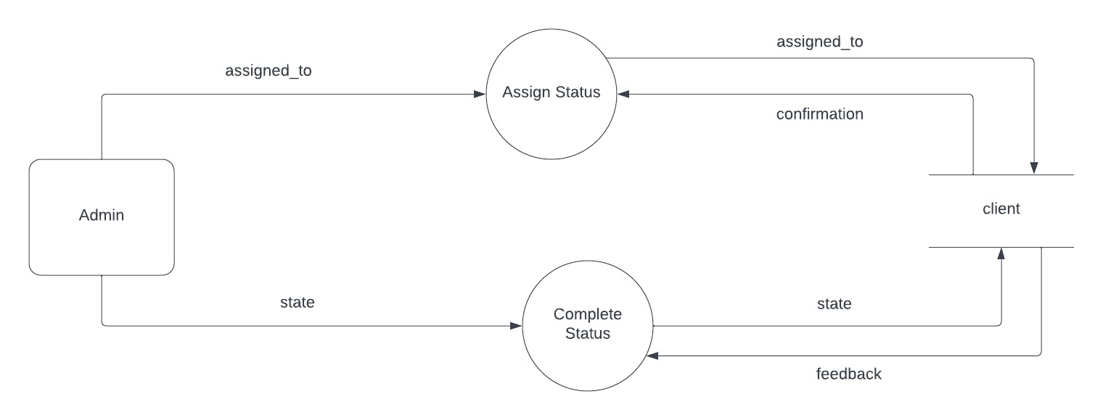

**Fig 2.6: Level 2 Data Flow Diagram (DFD)**

1. **ENTITY RELATIONSHIP DIAGRAM:**

Entity relationship diagram displays the relationships of entity set stored in a database. In other words, we can say that ER diagrams help you to explain the logical structure of databases. At first look, an ER diagram looks very similar to the flowchart. However, ER Diagram includes many specialized symbols, and its meanings make this model unique.

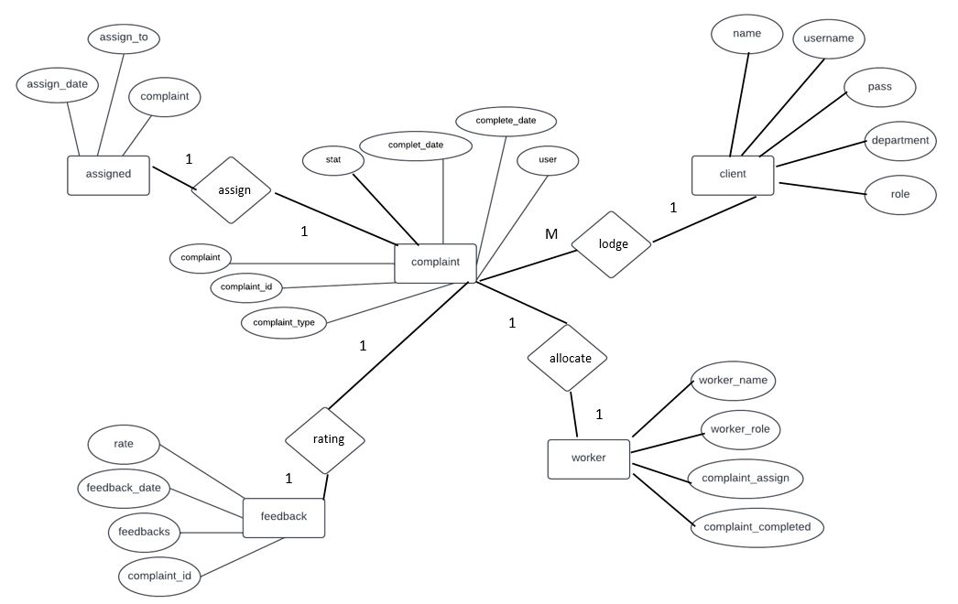

### Fig 2.7: Entity Relationship Diagram:

* 1. **DATABASE DESIGN:**

The information system of “Placement Tracker” performs its function with the help of the data store in certain repositories called Databases of the system. Detailed descriptions of the various databases included in the information systems are tabulated as follows:

### LOGIN DATABASE:

**Table 2.1: User Login Database**

|  |  |  |  |
| --- | --- | --- | --- |
| **No.** | **Field Name** | **Input** | **Output** |
| **1** | username | Character(x50) in length | This field is a mandatory field for a successful login. |
| **2** | name | Character(x50) in length | This field is a mandatory field for a successful login. |
| **3** | pass | Character(x500) in length | This field is a mandatory field for a successful login. |
| **4** | department | Character(x50) in length | This field is a mandatory field for a successful login. |
| **5** | role | Character(x20) in length | This field is a mandatory field for a successful login. |

* 1. **DATA DICTIONARY:**

A data dictionary is metadata repository or a centralized repository of information about data such as meaning, relationships to other data, origin, usage and format. The term may have one of several closely related meaning pertaining to databases and database management systems (DBMS):

A document describing a database or collection of databases. An integral component of DBMS that is required to determine its structure.

A piece of middleware that extends or supplants the native data dictionary of a DBMS.

**Table 2.2: client Table**

|  |  |  |  |  |  |  |
| --- | --- | --- | --- | --- | --- | --- |
| **No.** | **Column Name** | **Field Type** | **Size** | **Default** | **Constraints** | **Description** |
| **1** | username | Character | 50 | None | Primary Key | Username of the user |
| **2** | name | Character | 50 | None | Not null | Name of the user |
| **3** | pass | Character | 500 | None | Not null | Password of the user |
| **4** | department | Character | 50 | None | Not null | Department of user |
| **5** | role | Character | 20 | General | Not null | Role of user |

**Table 2.3: assigned Table**

|  |  |  |  |  |  |  |
| --- | --- | --- | --- | --- | --- | --- |
| **No.** | **Column Name** | **Field Type** | **Size** | **Default** | **Constraints** | **Description** |
| **1** | complaint_id | Character | 20 | None | Unique Key | Complaint Id of Complaint |
| **2** | assigned_to | Character | 50 | None | Not null | Assigned to the worker |
| **3** | assign_date | Date |  | current_timestamp() | Not null | Assign date of the Complaint |
| **4** | delay_reason | Character | 100 | None | Not null | Reason of Complaint Delay |

**Table 2.4: complaints Table**

|  |  |  |  |  |  |  |
| --- | --- | --- | --- | --- | --- | --- |
| **No.** | **Column Name** | **Field Type** | **Size** | **Default** | **Constraints** | **Description** |
| **1** | complaint | Character | 500 | None | Not null | Complaint done by the Client |
| **2** | complaint_type | Character | 50 | None | Not null | Type of Complaint |
| **3** | state | Character | 20 | pending | Not null | State of the Complaint |
| **4** | username | Character | 50 | None | Foreign Key | Complaint done by Username |
| **5** | complaint_id | Character | 20 | None | Primary Key | Complaint Id of Complaint |
| **6** | complaint_date | Date |  | current_timestamp() | Not null | Date of Complaint |
| **7** | complete_date | Date |  | None | Null | Date of Complaint Completed |

**Table 2.5: feedback Table**

|  |  |  |  |  |  |  |
| --- | --- | --- | --- | --- | --- | --- |
| **No.** | **Column Name** | **Field Type** | **Size** | **Default** | **Constraints** | **Description** |
| **1** | complaint_id | Character | 20 | None | Unique Key | Complaint Id of Complaint |
| **2** | feedbacks | Character | 500 | None | Not null | Feedback of Complaint |
| **3** | feedback_date | Date |  | current_timestamp() | Not null | Date of feedback |
| **4** | rate | Character | 10 | NULL | Null | Rating of Feedback |

**Table 2.5: workers Table**

|  |  |  |  |  |  |  |
| --- | --- | --- | --- | --- | --- | --- |
| **No.** | **Column Name** | **Field Type** | **Size** | **Default** | **Constraints** | **Description** |
| **1** | worker_name | Character | 50 | None | Unique Key | Name of the Worker |
| **2** | worker_role | Character | 50 | None | Not null | Role of the Worker |
| **3** | complaint_assigned | Integer | 10 | 0 | Not null | No of Complaint Assigned |
| **4** | complaint_completed | Integer | 10 | 0 | Not Null | No of Complaint Completed |

# CHAPTER – 3

**SCOPE OF IMPROVEMENT, SUMMARY AND CONCLUSIONS**

### SCOPE OF IMPROVEMENT:

* + - Integrate additional communication channels such as chatbots, social media platforms, or mobile apps to enable clients to lodge complaints conveniently through their preferred medium.
    - Incorporate predictive analytics to anticipate potential issues based on historical data,
    - Implement the backup mechanism for taking backup of database on a regular basis.
    - Extend support to multiple languages and regional variations to cater to a diverse clientele.

### SUMMARY:

The Works Department System is a dynamic and user-centric software solution aimed at enhancing customer satisfaction and streamlining complaint resolution processes. This project empowers clients to efficiently lodge complaints, track their progress, and contribute valuable feedback on service experiences. The Works Department System bridges the gap between clients and organizations, fostering open communication and transparency. By providing a platform for efficient complaint lodging, real-time tracking, and feedback collection, the project contributes to elevating customer satisfaction, improving service quality, and cultivating a positive brand image. Through its user-centric design and data-driven approach, the system reinforces the organization's commitment to excellence and continual improvement in customer service.

### CONCLUSIONS:

The completion of the Works Department System marks a significant stride forward in the realm of customer service and engagement. By providing clients with the ability to effortlessly lodge complaints, track their progress, and contribute valuable feedback, this project encapsulates a commitment to transparency, efficiency, and continuous improvement.

In a business landscape where customer satisfaction is a cornerstone of success, this system stands as a beacon of enhanced communication between clients and organizations. The seamless and intuitive user interface empowers clients to voice their concerns with ease, initiating a process that offers real-time updates on complaint resolution. This transparency not only reduces uncertainty but also fosters a sense of trust and confidence in the organization's dedication to addressing client needs.

# REFERENCES

1. Tailwind CSS - <https://tailwindui.com/components?ref=sidebar>
2. K.K. Aggarwal & Yogesh Singh, “Software Engineering”, 2nd edition, New Age International, 2005.
3. R.S. Pressman, “Software Engineering – A practitioner’s approach”, 5th edition, PHI Learning Private Limited.
4. Jeffery C. Jackson, “Web Technologies: A Computer Science Perspective”, Pearson.
5. Internet and World Wide Web Deitel HM, Deitel, Goldberg, Third edition.